2.1

1. Study penguins - X
2. Get up early -
3. Have breakfast
4. Get out in a boat
5. Visit different islands
6. Take photos
7. Have dinner
8. Work in the lab
9. Write emails
10. Go to bed late
11. Relax
12. Read a book

2, 4, 7, 11

3 2.1 Listen again.

1. In the summer my days are long. I GET UP early and HAVE BREAKFAST.

S + V1 (s, es)

S = Subject > He she it  
  
V1 = Fe’l

I work

We learn

You study

They read

He/She/It works

(bu holatda felga s yoki es qo’shiladi

I, we, you, they > Don’t + do

He,She,It > Doesn’t/ Does not + do

Do + I, we, you, they + do?

Does + he/she/it + learn play?

He has

He/she/it Agar fel ch, ss, s, x, z bilan tugasa (es qo’shiladi)

Har doim ravish to be dan keyin va V dan oldin keladi

To be = am is are

S + always/Never + Verb

I always, come on time

S + amlislare/Don’t/Can’t

2.3

1. S
2. Iz
3. S
4. Z
5. During the week he ALWAYS gets up early and he usually arrives at a volcano at seven o’cklock (always/ usually)
6. His work sometimes be dangerous and he never go alone > be – is / works
7. He usually returns to the research center at about 1 ocklock. And he always have launch in the lab > have – has
8. On Friday and Saturday nights he usually relax at home. He hardly ever go out with friends and he often go to bed early > relaxes, goes, goes

Wake up – uyqudan uy’gonmoq

Get up – uhlayotgan o’rnidan turmoq

Stand up - turmoq

Go home > go TO home bo’lmaydi

Go to bed > uxlamoq

Go to work/university > go to the bo’lishi mumkin farqi uyerga borib o’qisa the qo’shilmaydi, the qo’shilsa maqsad o’qish bo’lmasa

Have a shower

HOME WORK

2.1 not bookdan

2.2 ni yarimi

10.10.2024

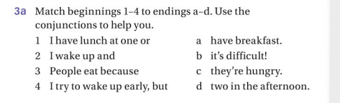

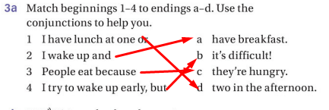

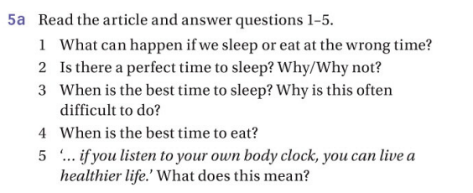

1. We will tired and hungry during the day.
2. No, because everyone’s body clock is different.
3. As Micheal Howell says the best time to sleep is six hours at night and two hours in the afternoon. Difficult? Because most people at work in that best time.
4. Best time to eat is two hours after you wake up and three hours before you go sleep.
5. Perhabs the most important thing to remember is that

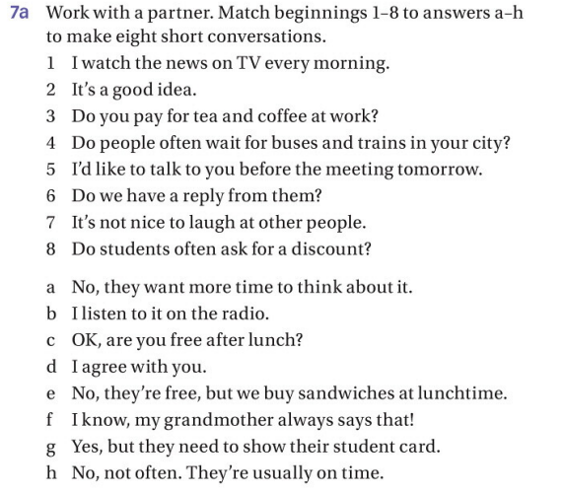

1. B
2. D
3. E
4. H
5. C
6. A
7. F
8. G

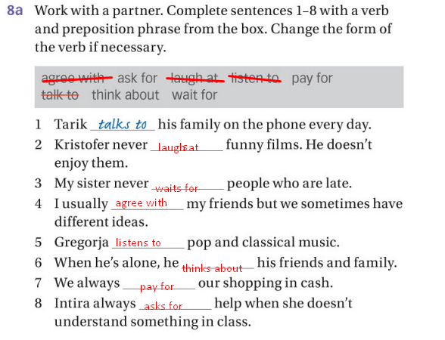

HOME WORK

2.2

2.3

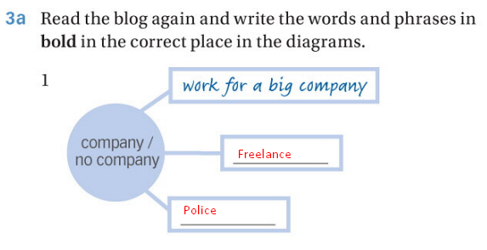

Home work

3.1

1. mechanic.

2. cleaner.

3. An airplane pilot.

4 A photographer.

5 A Student.

6 A musician .

7 A chef or cook.

8 A businessman (or office worker).

9 A musician playing a traditional instrument (could be specific to culture, like a lute player).

10 A doctor.

11 A dentist or dental hygienist

3.2

3.3 half

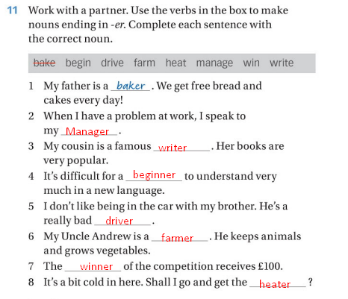

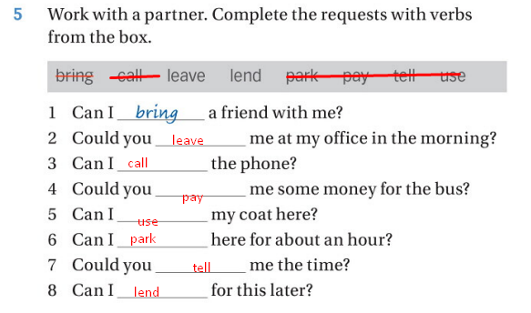

18 – oktyabr 2024

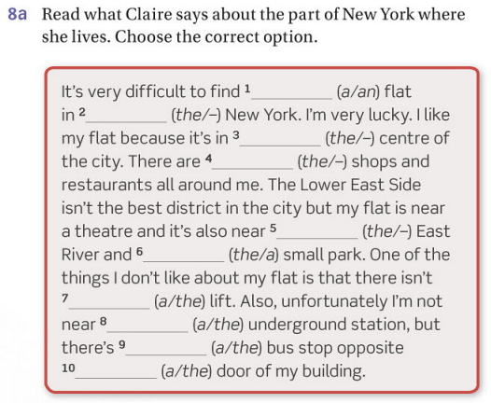

1. A flat
2. – new york
3. The centre
4. – shops
5. The East River
6. A small park
7. A lift
8. The underground
9. A bus
10. The door of my building

Home work 4.1, 4.2